Civil war in Liberia

UNSC Resolution: | 1478
Date of adoption: | 6-May-2003
Operative paragraph: | 8
Demand number: | 1478,0811

Sarah-Myriam Martin-Brûlé

Wording of demand

ensure unimpeded and safe movement for the personnel of United Nations humanitarian agencies and non-governmental organizations, end the use of child soldiers and prevent sexual violence and torture

List of addressees of the demand

Government of Liberia, Lima Militias, Liberians United for Reconciliation and Democracy, Movement for Democracy in Liberia

Short-term compliance

Description of the addressee(s)’ conduct

“From March through June, LURD forces came closer to Monrovia, attacking and retreating from IDP camps nearer the capital. At Jahtondo displaced persons camp, LURD attacked several weeks after the assault on Rick’s camp, causing civilians, some of whom had fled earlier assaults at outlying camps including Ricks, to flee once again. At Wilson Corner IDP camp, in early May, LURD fighters clashed with government troops, causing panic and flight among the civilian population. According to two child
soldiers, both the government forces and the LURD forcibly recruited children from the
two camps at that time.”
(...)
“Children also taken from Plumkor camp in May explained how they were abducted: “I
was caught on the road, just outside of camp, when fleeing the LURD attack. I was
taken to Bomi with a group of others and taught to fire, take cover and to kill.”12 Ellen
S., who later became a female commander, was taken that same day. “When LURD
came, they caught a lot of young girls and carried us to Bong County. They can force
you, you say no, but they carry you or they can beat you to death. They carried me to
train—to learn to fight, how to fire, to dodge bullets and how to kill somebody. The
training lasted two weeks.”
“Seventeen-year-old, Eric G. stated that he joined the LURD: After government militias beat and slapped me and held me in dirty water. On July 6, seven militia men came to my house, they tied my elbows behind my back and beat me. They raped my mother and two sisters in front of me. My youngest sister is sixteen years old. The seven of them took turns with them and I was forced to watch. So, I had to go and fight them to revenge my mother and sisters.15”

Human Rights Watch February 2004. “How to Fight, How to Kill: Child Soldiers in Liberia” .Vol. 16, No. 2 (A)
http://www.hrw.org/reports/2004/liberia0204/liberia0204.pdf

“22. With the recent political and military developments in Monrovia, the security situation in the country continues to improve. Liberia remains highly unstable, however, as armed groups, militia and criminal elements operate throughout the country. While there are no exact figures regarding the strength of the various armed groups, government forces are estimated to consist of some 20,000 to 30,000 elements, comprising armed forces of Liberia soldiers, militia formed outside the armed forces around local leaders and including a large number of child soldiers, and elite paramilitary personnel. The Government controls the greater Monrovia area and the centre of the country. The LURD rebel movement is estimated to have a strength of some 5,000 fighters concentrated primarily in western Liberia, while MODEL, which has an estimated 1,500 to 3,000 fighters, is operating in eastern parts of the country.”
(...)
“26. The armed conflict in Liberia has also resulted in serious violations and abuses of human rights and humanitarian law, including deliberate and arbitrary killings, disappearances, torture, widespread rape and sexual violence against women, girls and young boys, arbitrary arrests and detention, forced conscription, recruitment and use of child soldiers, systematic and forced displacement, and indiscriminate targeting of civilians. Of the estimated 250,000 people who have lost their lives in war-related circumstances since 1989, at least half were civilian non-combatants. There are eyewitness accounts of massacres of civilians and reports of mass graves, some dating back to the early 1990s. All sides have been responsible for violations and abuses. Torture was widely used by all parties to the conflict. Government militias, police and paramilitary units are known to maintain torture chambers.. The conflict militarized Liberian society with a proliferation of militia groups that lacked any statutory command and control structures. Children were forcibly recruited and constituted a substantial portion of the fighting forces on all sides. Estimates indicate that one out of every 10 children may have been recruited at some time or another into the war effort.”

Report of the Secretary-General to the Security Council on Liberia , 11 september 2003

“14. Humanitarian activities in Liberia have experienced severe constraints for more than a year because of insecurity, and there has been only limited or sporadic access to vulnerable populations. Since March 2003 humanitarian access has been further restricted to approximately 20 per cent of the country, which means that the large majority of Liberia’s population cannot receive any humanitarian assistance. This situation has deteriorated still further since the fighting in Monrovia during the month of June. Although there are substantial food reserves in Monrovia, insecurity has hampered food distribution and cash shortages have limited the commercial availability of food. As a result there are reports that malnutrition, particularly among children under 5, is on the rise because the environment is simply not safe enough for any sustained humanitarian operations. Humanitarian agencies are able to provide water and sanitation services to only a fraction of the internally displaced population.
15. In and around Monrovia, looting and robbery are widespread. Reports of human rights violations, including sexual violence and abuse, are persistent and residents in the makeshift camps complain of continued harassment by armed groups. Desperate people are unable to forage for food because they fear for their lives.”

Report of the Secretary-General in pursuance of paragraph 19 of resolution 1478 (2003) concerning Liberia, 5 August 2003

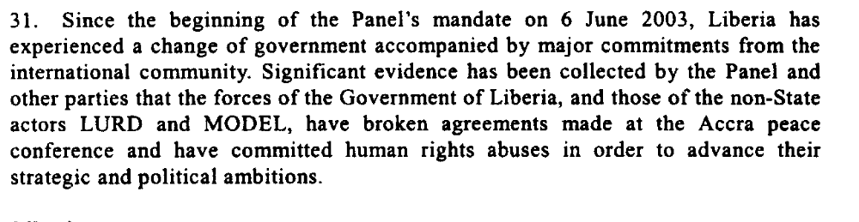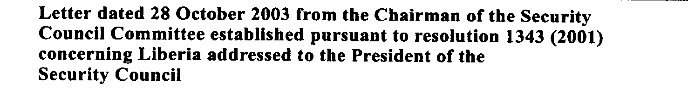

Assessment

Short-term compliance
X No or marginal compliance (1) | Medium low compliance (2) | Medium high compliance (3) | Full or almost full compliance (4)

Considerations underlying the assessment
Within the six months following the adoption of the resolution, the parties have impeded and threatened the movement for the personnel of United Nations humanitarian agencies and non-governmental organizations. The demand addressees continued the use of child soldiers and committed sexual violence and torture

Medium-term compliance

Description of the addressee(s)’ conduct

30. Liberia’s protracted conflict has had terrible consequences for the civilian population, including the Sierra Leonean and Ivorian refugees as well as thirdcountry nationals who had sought asylum in the country. Nearly 1 million Liberians, or a third of the population, are displaced. In addition to some 500,000 internally displaced persons, about 300,000 Liberians are refugees in neighbouring countries. Some 50,000 refugees from Sierra Leone and Côte d’Ivoire remain in the country. The recent spread of fighting to Monrovia further aggravated the situation, as internally displaced persons and refugees were subjected to repeated abuse and most urban residents were made vulnerable. Civilians were not only the accidental victims of the fighting but also direct targets of armed groups who unleashed a campaign of terror against them. The evacuation in June 2003 of most international aid personnel left the civilian population with virtually no international protection or support. Despite the situation, United Nations national staff continued essential humanitarian interventions.
Report of the Secretary-General, 11 September 2003

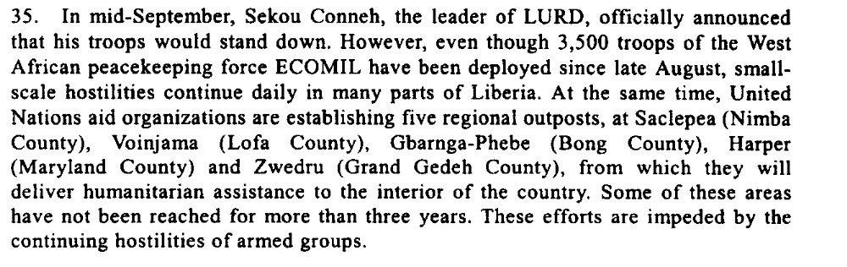

“Riots broke out and road blocks were erected as fighters demonstrated against UNMIL troops. From 7 to 9 December 2003, Monrovia witnessed looting, including cars stolen and heavy shooting, particularly in the red light district (Paynesville), home to GOL fighters. The result was nine dead (suspected GOL) and one wounded UNMIL peacekeeper. “

ICG. 2004. “ Rebuilding Liberia: Prospects and Perils”. 30 January. ICG Africa Report No.75.
http://www.crisisgroup.org/library/documents/africa/west_africa/075_rebuilding_liberia_prospects.pdf

“In Monrovia, many expatriates and some Liberians describe the continuing existence of rebel group command and control structures as a problem. The RAND Corporation report stated that “rebel group structures and command chains have not been eradicated and
remain a concern”.15 Villagers offer a more mixed view. Those living near the Guthrie rubber plantation when it was under the control of mostly LURD-affiliated excombatants had a variety of complaints, including theft, rape with impunity, the beating of village elders to cow them into silence and the luring of some young men into criminal behaviour. “

ICG. 2009. Liberia: Uneven Progress in Security Sector Reform.
Africa Report N°148 – 13 January
http://www.crisisgroup.org/library/documents/africa/west_africa/148_liberia___uneven_progress_in_security_sector_reform.pdf

Assessment

Medium-term compliance
No or marginal compliance (1) | X Medium low compliance (2) | Medium high compliance (3) | Full or almost full compliance (4)

Considerations underlying the assessment

Within the two years following the adoption of the resolution, the parties have impeded and threatened the movement for the personnel of United Nations humanitarian agencies and non-governmental organizations. The demand addressees continued the use of child soldiers and committed sexual violence and torture.

Depth of demand

Assessment

Level of depth of demand
X Low depth of demand (1) | Medium depth of demand (2) | High depth of demand (3)

Considerations underlying the assessment

The demand did not put the survival of the demand addressees at a significant risk nor did it impact on its chances to win power.

Level of confidence about coding decisions

Level of confidence about coding decision
Extremely high | X high | Moderate

Comments to IPI (if any)

Given the high proportion of child soldiers used by each demand addressees, the demobilization of the young fighters might have impeded the strength and size of some of the demand addressees (mostly the LURD).

